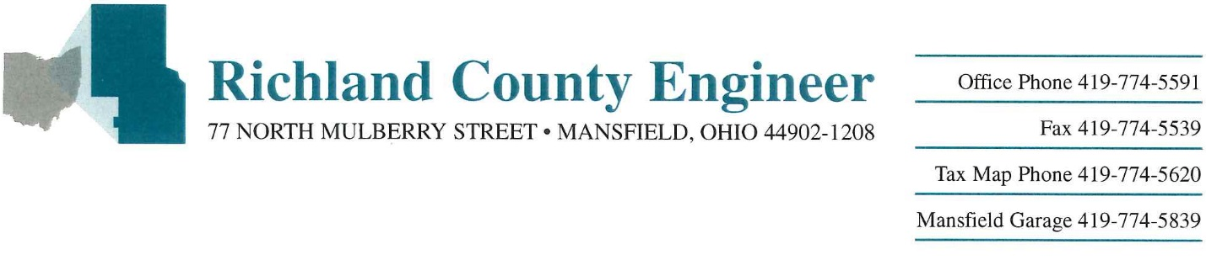

Utility Permit Application
{Click within the brackets, [ ], then type; delete any additional blank spaces; save document; print out; sign & date it at the bottom; then send back to Richland Co.}

Date:

Company Name (THE UTILITY):

Company Contact Information (Address, Phone #, Email, etc.):

RE: Utility Installation – Permit Terms & Conditions, for usage of the Public Road Right-of-way for Utility Installations, Road Bores & Temporary Construction Drive permit request

Description / Location:

Conditions:
- THE UTILITY agrees that any facility installed under the terms of this Agreement will be relocated at its expense. They may not interfere with the contemplated construction, reconstruction, improvement, maintenance, repair, or use of County roads or highways. The relocation within the bounds of the road or highway shall be the manner and to the extent prescribed by the Richland County Engineer, and according to the plans approved by the Richland County Engineer.

- The Contractor agrees to indemnify and hold harmless the Owner, its agents, employees or any other person against loss or expense including attorneys’ fees, by reason of any liability imposed by law upon the Owner, for damage because of bodily injury, including death, at any time resulting therefrom, sustained by any person or persons, or on account of damage to property arising out of or in consequence of this agreement, whether such injuries to persons or damage to property are due or claim to be due to any passive negligence of the Owner, its employees or agents or any other person. In order to give effect to the intention of the parties in forming this agreement and in order to facilitate all indemnification to the Owner, the Contractor expressly,
intentionally and irrevocably waives any and all employer immunity provided in Section
35,Article II of the Ohio Constitution. It is further understood and agreed that the Contractor shall (at the Option of the Owner) defend the Owner with appropriate counsel and shall further bear all cost and expenses, including the expense of counsel, in the defense of any suit arising hereunder.

- THE UTILITY shall clean-up all debris and materials resulting from its operations and restore all surfaces, structures, culverts, pipes, ditches, pavement and property to its original or better condition to the satisfaction of the Richland County Engineer.

- All work shall be performed at no cost to Richland County.

- All walks, steps, driveways, drains, roadside ditches, mail boxes, traffic signs, guardrail, poles, fences, etc. that are disturbed must be restored by THE UTILITY to their original condition or better.

- Local traffic, facilities for pedestrian and vehicular ingress and egress, shall be provided at all times by THE UTILITY for the property adjacent to the work.

- Two-way traffic shall be maintained at all times and all equipment used on pavement by THE UTILITY shall be rubber tired or approved methods shall be utilized to protect the pavement.

- All work requiring workers or vehicles on the pavement or shoulders shall comply with all of the requirements of the Ohio Manual of Uniform Traffic Control Devices and Item 614 (Maintaining Traffic) of the Ohio Department of Transportation Construction and Material Specifications. Failure to comply with this requirement will be cause for immediate suspension of the work until the proper traffic controls have been provided.

- The pavement shall be kept clean at all times from mud and material carried onto the pavement. Failure to comply with this request will result in suspending all operations on County Right-of-Way while working under this Agreement.

- All bore pits or manholes left open by THE UTILITY during non working hours must be backfilled or plated and fenced for safety.

- The bore pits shall be located a minimum of ten (10) feet from the edge of pavement and shall not be moved either right or left of the designated plan site without permission being granted by the Richland County Engineer.

- All County road pavement shall be bored by THE UTILITY and the cable/conduit shall be installed a minimum of five (5) feet below the pavement surface. The minimum length of the bore shall be the width of the pavement plus ten (10) feet on each side of the ditch line, unless otherwise noted.

- All poles, down guy anchors, meters, regulators, pedestals, utility vaults, handholes and other above ground features shall be a minimum of ten (10) feet from the edge of pavement.

- Richland County is only granting the right to extend the line within the authority of the highway easement. If required, it is the responsibility of THE UTILITY to obtain the right to install the line from the underlying property owner interests.

- The Richland County Engineer reserves the right to require a casing pipe to be installed based upon conditions or hazards involved at the site.
- The minimum depth of cover of any buried line under a roadside ditch shall be three (3) feet and six (6) feet under any stream crossings.

- THE UTILITY shall either become a member of the Ohio Utilities Protection Service or install permanent information signs at reasonable intervals indicating the ownership of the line and a telephone number to call in case of an emergency or otherwise.

- THE UTILITY shall install the new line as near to the public right-of-way line as is practical.

- Permittee occupying any part of a highway, bridge, or culvert in the county, under and by virtue of a franchise legally granted shall relocate their properties within the bounds of such highway, bridges, or culverts when in the opinion of the county engineer, they constitute obstructions or interfere with the construction, improvement, maintenance, or repair of such highways, bridges, or culverts, or the use thereof by the public. Upon the Engineer rendering such opinion, the Board may revoke this permit in its sole discretion. The Permittee shall be responsible to relocate structure(s) at Permittee’s own expense.

- THE UTILITY shall submit to the Richland County Engineer a progress schedule listing when various work phases will be completed. If the line construction is not completed within one year from the date of this Agreement then this Agreement shall be null and void.

Please send a set of detailed plans and sign below and send this permit application via email to kpayne@rcengineer.com or to: Richland County Engineer’s Office, 77 North Mulberry St., Mansfield, OH 44902, Att’n.: Utility Permit Coordinator.

By signature below, THE UTILITY agrees to the above terms and conditions:

THE UTILITY:

Signature & Title:

Print Name: ; Phone #:

Date:

If you have any questions, please contact: Kevin Payne, P.E., P.S.; ph. 419-774-5833, e-mail kpayne@rcengineer.com .

With the below Richland County Engineer’s office signature & Richland County Commissioners signatures, THE UTILITY is authorized to proceed, at no cost to the County, with your installation work. Please notify the Richland Co. Engineer’s office at least one week prior to beginning your work. Any disturbed areas must be repaired. This permit is only for work within the Richland County highway right-of-way as mentioned in the above “Location”.

Official Use Only:
Recommended by:

________________________________ _________________________
Richland County Engineer Official (Name) / Title

________________________________ _________________________
Richland County Engineer Official (Signature) / Date

________________________________ _________________________
Approval Date Board of Richland County Commissioners

